**192011095**

**G.Harish**

**USING RAPTOR – SWAP TWO CHARECTERS**

**FLOWCHART**

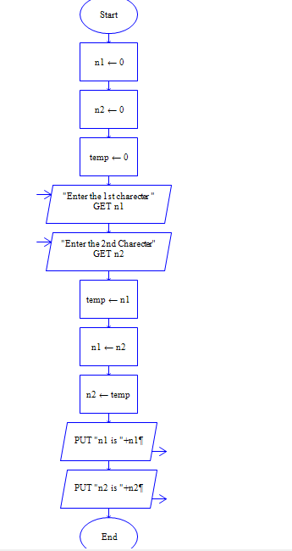

**OUTPUT**

INPUT

N1 =V

N2 = R

